E - COMMERCE

The websites where users can buy the products for their general requirements

**Navigation bar (on top)**

* Company name
* Avatar button (login/create account)
* Search bar
* Cart

**Advertisements and offers and banners section**

**Filters**

* Sort by price
* User rating
* Price ranges
* Popular brands
* discount

**Item’s list**

* Each item in separate division.
* Image of item and name
* Option to buy and add to cart
* Increase the quantity of item
* User rating
* Discount offers if available

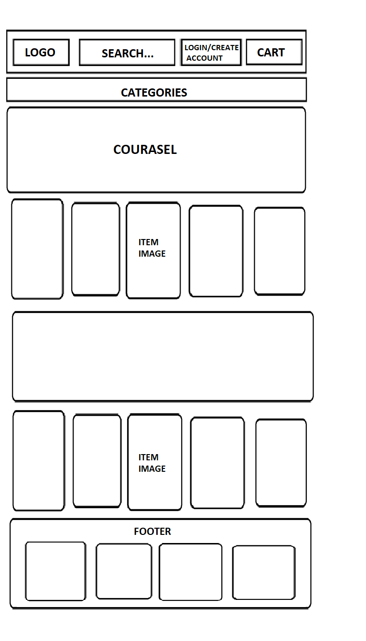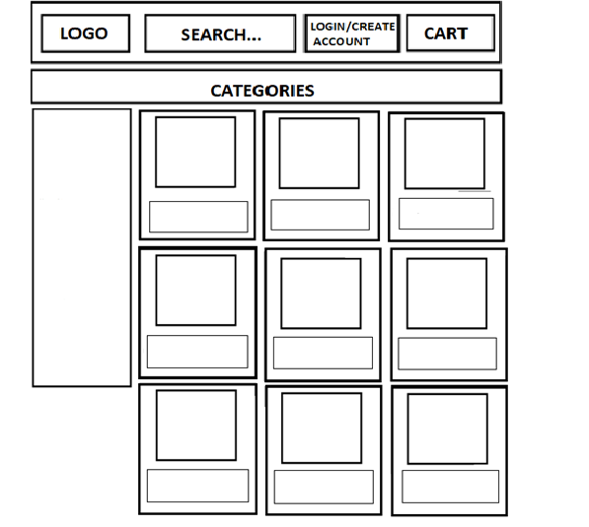

**Advertisement and discount offers**

price

Item image

image

Filters

By item

By price